Appendix 1: Assignment submission cover sheet
ASSIGNMENT SUBMISSION COVER SHEET

Student Id:
CSE25-216

Student names:
KEFILWE MARAKALALA
Student email:
CSE 25-216@thuto.bac.ac.bw

Cohort:
2026

Assignment title:
SCIS WMD_2026 A01

Date of submission:
20/03/2026
Programme of Study:
Bsc hons Computer systems engineering

Year of Study:
YEAR 1

Intellectual property statement
By checking the box below, I certify that this assignment is my own work and is free from plagiarism. I understand that the assignment may be checked for plagiarism by electronic or other means and may be transferred and stored in a database for the purposes of data-matching to help detect plagiarism. The assignment has not previously been submitted for assessment in any other unit or to any other institution. I
have read and understood the Botswana Accountancy College plagiarism guidelines policy.
Agree Signature……k.m…a…ra…ka…la…la………
Date……2…0…/0…3/2…0…26……………

NBFIRA
Non-Bank Financial Institutions Regulatory Authority

WEB SPECIFICATIONS
EXISTING WEBSITE

Purpose of the New NBFIRA Website
The website serves as the official digital face of the regulatory authority — a trusted, publicly accessible platform that communicates NBFIRA's regulatory role to multiple audiences simultaneously.
Project Objectives
- Deliver a modern, accessible, and mobile-responsive website for NBFIRA
- Improve usability for consumers, regulated entities, and the general public
- Provide clear navigation to key services: licensing, complaints, resources, and consumer education
- Reflect NBFIRA's mandate as a credible and professional regulatory authority
- Ensure the site is maintainable by non-technical staff
- NBFIRA now oversees new sectors like VASPs (Virtual Asset Service Providers) that didn't exist when the original site was built. The site needs to reflect this expanded mandate.
- NBFIRA benchmarks itself against bodies like the FSB (South Africa), FCA (UK), and IOSCO. Their websites are modern, well-structured, and informative — NBFIRA should match that standard.

Project Scope
The project covers the design and development of a static HTML/CSS/JavaScript website with the following pages:

Objectives

1. Inform & Educate
- Explain NBFIRA's mandate, vision, and mission clearly to the public
- Help consumers understand their rights when dealing with non-bank financial institutions
- Provide financial literacy resources and guides

2. Regulatory Transparency
- Publish laws, directives, guidelines, and annual reports
- Make the regulatory framework accessible to licensed entities and the public
- Show which sectors NBFIRA oversees (insurance, pensions, capital markets, VASPs, etc.)

3. Consumer Protection
- Give consumers a direct channel to lodge complaints against NBFIs
- Allow the public to verify whether an institution is licensed
- Provide contact routes (phone, email, online form)

4. Industry Communication
- Announce new regulations, guidance notes, and circulars
- Share news, events, and conference participation
- Keep regulated entities updated on compliance requirements

5. Institutional Credibility
- Project professionalism and authority through design
- Align with international regulatory body standards (like FCA, FSB)
- Build public trust in Botswana's non-bank financial system

6. e-Services Access
- Provide a gateway to the online portal for licence applications, renewals, and submissions
- Reduce physical visits to NBFIRA offices through digital self-service

Target Audiences (from Audience Definition)
Audience | Their Need
General public / consumers | Complaints, licence checks, financial education
Regulated institutions | Compliance info, forms, circulars
Investors & analysts | Reports, statistics, market data
Media | News, press releases, spokesperson contacts
Job seekers | Careers page

Why Redesign the NBFIRA Website?

1. Outdated Design & Poor User Experience
The current NBFIRA website has an older visual design that doesn't reflect the authority and professionalism expected of a national financial regulator. Users may struggle to find what they need quickly.

2. Mobile Responsiveness
Many Batswana access the internet via mobile phones. The old site likely wasn't optimized for smaller screens, making it hard to navigate on the go.

3. Information Architecture Problems
Key information — like how to file a complaint, verify a licence, or find regulations — may be buried or hard to locate, failing both consumers and regulated entities.

4. Growing Regulatory Scope
NBFIRA now oversees new sectors like VASPs (Virtual Asset Service Providers) that didn't exist when the original site was built. The site needs to reflect this expanded mandate.

5. Consumer Protection Push
There's a stronger global and local emphasis on financial consumer protection. The website needs to be a clear, accessible channel for the public — not just industry professionals.

6. Credibility & Trust
A regulator's website is a signal of institutional strength. An outdated site can undermine public confidence in the authority itself.

7. e-Services Integration
Moving government and regulatory services online is a national priority in Botswana. The new site needs to properly integrate with the e-Services portal for licence applications, renewals, and submissions.

8. Alignment with International Standards
NBFIRA benchmarks itself against bodies like the FSB (South Africa), FCA (UK), and IOSCO. Their websites are modern, well-structured, and informative — NBFIRA should match that standard.

NBFIRA
Non-Bank Financial Institutions Regulatory Authority

INFORMATION DESIGN AND TAXONOMY
Development Standards, Stack, and Architecture

1. INTRODUCTION
This document defines how information is structured, labelled, and organised across the NBFIRA website. It covers the site taxonomy (content categories and naming), navigation hierarchy, page content models, and labelling conversions. This document guides both the development team and content editors.

2.TARGET AUDIENCE
USER | WHAT THEY COME FOR
General public/ consumers | File complaints, check licences, and understand rights
Regulated institutions | Find circulars, submit returns, and apply for licences
Researchers / Analysts | Download reports, access statistics
Media | Press releases, news, Contacts
Job seekers | Vacancies

3.SITE TAXONOMY

The taxonomy of the site structures the topic hierarchy and navigation
Hierarchy level 0 — the homepage (root of everything)
Hierarchy level 1 — the 6 main nav items: About Us, Regulation, Sectors, Publications, Consumers, News
Hierarchy level 2 — the sub-pages under each section (e.g. under Consumers: Lodge Complaint → Verify Licence → Financial Education)
The 3-click rule — a core principle of good taxonomy. Any user should reach their destination in 3 clicks or fewer:

LABEL | URL
HOME | /index.html
REGULATION | /regulation.html
SECTORS | /sectors.html
PUBLICATION | /publication.html
NEWS | /news.html
CONSUMERS | /consumers.html
E-PORTAL SERVICES | /e-portal.html
FEEDBACK | /feedback.html

SITE MAP
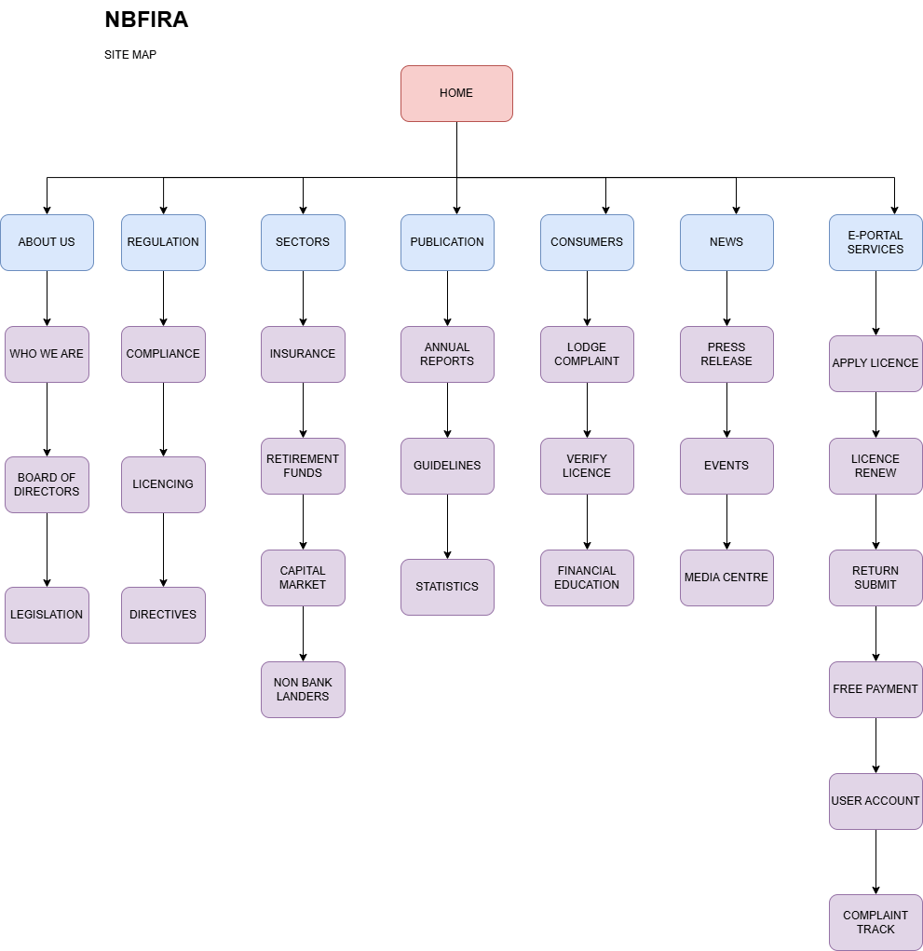

Flowchart
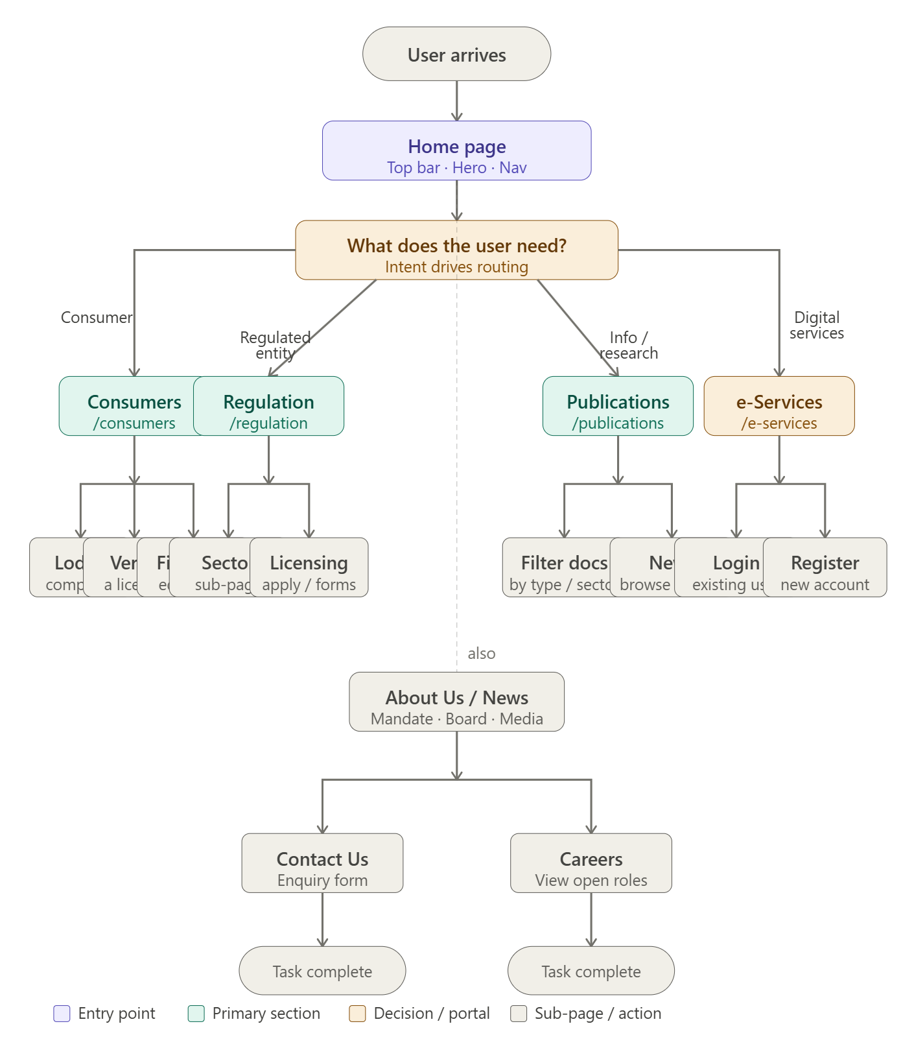

4. CONTENT MODEL PER PAGE

4.1 Home page

SECTION | CONTENT TYPE | NOTES
Top Bar | Address, phone number, email, top nav links | Text, email, link list
Hero Section | Eyebrow text, Headline, Sub headline, primary CTA label, Primary CTA URL, Secondary CTA label, Secondary CTA URL, Hero image/ background | Text, Rich Text, Text area, Text, URL, Text, URL, image
Hero stats cards | Stats Number/ Value, Star label, Card width | Text, Text, Select
News Ticker | Ticker items | Text list
Sectors section | Section label, Section title, Section subtitle | Text, Text, Text area
Sectors card (repeatable, up to 8) | Icon/ Emoji, Sector Name, Short Description, Stat/Tag line, Link URL | Emoji, Text, Text area, Text, URL
Mandate Strip | Item 1- Mandate  Item 2-Vision  Item 3-Mission | Text area, Text area, Text area
Latest News Section | Section Label, Section Title, View All URL, Featured Article | Text, Text, URL, Reference

4.2 About us
- Page Header- Page Title, Breadcrumb, Hero/ Banner Image, Intro paragraph
- Our Mandate- Mandate Statement, Mandate Highlights
- Vision & Mission- Vision Statements, Mission Statements, Core values
- History/ Timeline- Timeline Items
- Boards & Management- Section Title, Board Member Name, Board Member Title/ Role, Board member photo, Board Member Bio
- Legislation- Act Name, Act Description, Act Document, Subsidiary Legislation

4.3 Regulation
- Page Header- page title, intro paragraph, Regulation Framework Document
- Sectors Card- Icon, Sectors name, Short Description, Stat/Tag, Link URL
- Licensing-How to apply, Application Forms, Licencing fees, Contact for licencing

4.4 Sector
- Page header- Sector Name, Breadcrumb, Sector icon, Sector Tag, Intro paragraph
- Regulatory frame- Framework Description, Key legislation, Guidelines/ directives
- Licensing in this sector- Who needs a licence, Application process, Application forms, Current licences
- Compliance and reporting- Reporting requirements, Compliance deadlines, Reporting templates
- Related publications- Related Documents
- Content/ Enquiries- Sector contact names, sector contact Email, Sector contact phone

4.5 PUBLICATION
- Page Header- page title, Intro
- Filter/ Search bar- Search, Filter by type, filter by sector, filter by year
- Document- Document title, Documnt Type, Sector tag, Publication date, Document file, Short desciptio, Version/ Reference no, Status .

4.6 News
- Page header- page title, Featured or Hero article
- Filter bar- Filter by category, Filter by year, Search
- News article- Article title, Category/tag, Sector tag, Publication date, Hero image, Summary, Full body content, Author, Related documents , related articles.

4.7 Consumers
- Page header-Page title, intro paragraph
- Quick action link- Icon, Link label, Short description, URL
- Complaint Submission- Section title, Instructions, complaint form, Contact fall back
- Verify a licence- Instructions, Licence Search widget, Registered entities list.
- Know your rights- Rights overview, Rights Documents, FAQs
- Financial education- Section title, Resources, outreach Events

4.8 E-services Portal
- Page header-page title, intro, Login CTA, Register CTA
- Service card- service name icon, short Description, who it is for, Service URL, Availability.
- Help and support- User guide, FAQs, Support Contact

NBFIRA
Non-Bank Financial Institutions Regulatory Authority

TECHNICAL BRIEF
Development Standards, Stack, and Architecture

1. Overview
This Technical Brief outlines all technologies, software tools, and resources selected for the development of the NBFIRA website redesign. Each technology has been chosen to match the complexity, security requirements, and audience needs of a national financial regulatory authority's official web presence.

2. Core Web Technologies
The following foundational technologies will form the structure, presentation, and interactivity of the website:

Category | Tool / Technology | Purpose / Justification
Structure | HTML5 | Semantic markup for all pages. Ensures accessibility, SEO, and screen-reader compatibility required for a government-facing site.
Styling | CSS3 | Layout, responsive design, animations, and visual theming. CSS variables used for consistent navy and gold brand colours across all pages.
Interactivity | JavaScript (ES6+) | Dynamic elements such as the news ticker, mobile menu toggle, search filtering, and form validation on the complaint lodge form.
Responsiveness | CSS Flexbox & Grid | Ensures the website renders correctly on mobile, tablet, and desktop — critical as most Batswana access the internet via mobile devices.

3. Frontend Framework & Libraries
To accelerate development and ensure consistency across components, the following frameworks and libraries will be used:

Category | Tool / Technology | Purpose / Justification
UI Framework | React.js | Component-based architecture for building reusable UI elements such as sector cards, news feeds, and the document library.
Routing | React Router | Enables multi-page navigation within the single-page application structure without full page reloads.
Styling Framework | Tailwind CSS | Utility-first CSS framework for rapid, consistent styling. Avoids bloated CSS files and enforces design system constraints.
Animations | CSS Keyframes / Framer Motion | Powers the hero section entrance animations, card hover effects, and news ticker scroll animation.
Icons | React Icons / SVG | Lightweight, scalable icons for sector cards, navigation, and consumer portal links.

4. Backend Technologies & CMS
To support dynamic content such as news posts, publications, and the e-Services portal, a backend system is required:

Category | Tool / Technology | Purpose / Justification
Backend Language | Node.js + Express | Lightweight server-side framework. Handles API requests for the e-Services portal, complaint submissions, and licence verification queries.
Database | PostgreSQL | Relational database for storing regulated entity records, user accounts, complaint data, and publication metadata.
CMS | Strapi (Headless CMS) | Allows NBFIRA staff to publish news articles, upload publications, and update regulatory notices without developer intervention.
Authentication | JWT (JSON Web Tokens) | Secures the e-Services portal — required for licence applications, returns submissions, and complaint tracking by registered entities.
File Storage | AWS S3 / Cloudflare R2 | Stores and serves PDF publications, annual reports, and guidance notes with reliable uptime and fast download speeds.

5. Design & Graphics Tools
The following tools will be used during the design, prototyping, and asset creation phases of the project:

Category | Tool / Technology | Purpose / Justification
UI/UX Design | Figma | Primary design tool for creating wireframes, mockups, and the final page layout sketches. Supports real-time team collaboration and client feedback.
Logo & Vector Graphics | Adobe Illustrator | Used to create or refine the NBFIRA logo, vector icons, and any custom SVG graphics used across the site.
Photo Editing | Adobe Photoshop | Optimises images for web use — resizing, compression, and colour correction of any photography used on the site.
Prototyping | Figma Prototyping | Interactive click-through prototype shared with stakeholders for feedback before development begins.
Colour & Branding | Adobe Color | Used to define and validate the navy blue (#0B1F3A) and gold (#C89B3C) brand palette and ensure WCAG accessibility contrast ratios are met.
Favicon & Small Icons | RealFaviconGenerator | Generates browser tab icons and PWA icons in all required sizes from the NBFIRA logo.

6. Development Environment & Tools

Category | Tool / Technology | Purpose / Justification
Code Editor | Visual Studio Code (VS Code) | Industry-standard editor with extensions for HTML, CSS, JavaScript, React, and Git integration.
Version Control | Git + GitHub | Source code management. Enables team collaboration, change tracking, and rollback capability if errors are introduced.
Package Manager | npm (Node Package Manager) | Manages all frontend and backend library dependencies and build scripts.
Build Tool | Vite | Fast frontend build tool and development server. Replaces Create React App for faster hot-module reloading during development.
API Testing | Postman | Tests all backend API endpoints for the e-Services portal before connecting to the frontend.
Browser Testing | Chrome DevTools + BrowserStack | Tests layout, performance, and responsiveness across Chrome, Firefox, Edge, and Safari on multiple device sizes.

7. Hosting & Deployment Infrastructure

Category | Tool / Technology | Purpose / Justification
Web Hosting | Vercel (Frontend) | Deploys the React frontend with automatic HTTPS, global CDN, and continuous deployment from GitHub.
Backend Hosting | Railway / Render | Hosts the Node.js/Express backend API and PostgreSQL database with automatic scaling.
Domain | nbfira.org.bw (existing) | Existing government-registered domain. DNS records updated to point to new hosting infrastructure.
SSL Certificate | Let's Encrypt / Vercel TLS | Ensures all traffic is encrypted via HTTPS — mandatory for a financial regulatory authority website.
CDN | Cloudflare | Content Delivery Network that caches static assets globally, reducing load times for users across Botswana.

8. Accessibility & Performance Standards
Given that NBFIRA serves the general Botswana public, the website must meet the following standards:

- WCAG 2.1 Level AA compliance — sufficient colour contrast, keyboard navigation, and screen reader support
- Google Lighthouse score target: Performance 90+, Accessibility 95+, Best Practices 90+
- Page load target under 3 seconds on a standard mobile connection
- All PDF publications must include accessible text layers (not scanned images)
- Multilingual readiness — English primary, Setswana support to be added in Phase 2

9. Technology Stack Summary
The table below provides a concise summary of the complete technology stack:

Frontend | HTML5, CSS3, JavaScript ES6+, React.js, Tailwind CSS
Backend | Node.js, Express.js, PostgreSQL
CMS | Strapi (Headless)
Design Tools | Figma, Adobe Illustrator, Adobe Photoshop
Dev Tools | VS Code, Git/GitHub, Vite, npm, Postman
Hosting | Vercel (frontend), Railway (backend), Cloudflare CDN
Security | JWT Auth, HTTPS/TLS, Cloudflare DDoS protection
Standards | WCAG 2.1 AA, Google Lighthouse, responsive design

